

Two Distributed Reactive MPLS Traffic Engineering Mechanisms for
Throughput Optimization in Best Effort MPLS Networks

Stefan Butenweg
TU Mьnchen
Institute of Communication Networks
80290 Munich, Germany
stefan.butenweg@ei.tum.de

Abstract

This paper describes a scalable distributed reactive
MPLS traffic engineering system, which can be used for
throughput optimization of Best Effort traffic in IP
networks. The load rebalancing in the system is realized
either by path rerouting or by multi path balancing. To
prevent the system from routing oscillations, the
distributed traffic engineering units coordinate the load
rebalancing actions by using routing update messages. It
is shown by simulation, that the reactive MPLS traffic
engineering system performs well in great networks and
optimizes the network throughput dramatically compared
to shortest path routing. The path rerouting and multi
path balancing approach reach comparable results while
the multi path balancing performs slightly better in the
presented scenario. To evaluate the reactive MPLS traffic
engineering approaches in realistic network scenarios, a
scalable rate based simulation environment is used.

1. Introduction

Reactive traffic engineering reacts to undesired load
distributions in a network and optimizes the network
performance by rebalancing load during network
operation. Unexpected traffic variations are caused e.g. by
link failures in the own or in neighboring networks, by
changes of the BGP metrics or by new web content.
A basic technology to perform traffic engineering in
IP networks is Multiprotocol Label Switching. MPLS
establishes tunnels (Label Switched Paths LSP) in an IP
network and transports an arbitrary aggregate of IP flows
over an LSP. Reactive MPLS traffic engineering is
realized either by rerouting LSPs or by redistributing the
load over two or more LSPs, which connect the same
Label Switched Routers LSRs.

To be able to react to unexpected traffic variations, a
reactive traffic engineering system monitors the network
load. Basing on this information, the traffic engineering
units calculate a load rebalancing. The task of the
rebalancing calculation algorithm is to improve an
undesired load distribution towards an acceptable load
distribution in a minimum amount of time and with a
minimum amount of rebalanced data. Additionally the
rebalancing algorithm has to be simple and fast due to
online calculation during network operation. A special
requirement of distributed reactive traffic engineering is
to prevent the system from routing oscillations due to
uncoordinated concurrent load rebalancing actions.
In this paper a scalable reactive distributed MPLS
traffic engineering system is presented, which performs
path rerouting as well as multi path balancing. Section 2
gives an overview over related work and describes the
innovation of this proposal. Section 3 presents the
reactive MPLS traffic engineering system with the
integrated path rerouting and multi path balancing
algorithm and discusses the system stability. Section 4
defines the simulation environment for the performance
investigation and section 5 shows the simulation results.
Section 6 summarizes the paper.

2. Related work

There are several proposals, which discuss reactive
MPLS traffic engineering. In [1] the MPLS Adaptive
Traffic Engineering system MATE is described. MATE is
based on a distributed multi path balancing approach. The
source routers perform an active measurement of each
LSP by sending probing packets and measuring the delay
jitter and the loss of the packets. The calculation of the
new load distribution relies on the optimal routing with
the gradient projection algorithm [6]. The traffic
engineering capable routers perform rebalancing actions
without coordination. To prevent the system from routing

Proceedings of the Eighth IEEE International Symposium on Computers and Communication (ISCC’03)
1530-1346/03 $17.00 © 2003 IEEE

oscillations due to concurrent rebalancing actions, each
LSR adapts the load distribution of its LSPs with a limited
step size. After each load rebalancing action, the LSPs are
measured again. Because the step size decreases with an
increasing network size and the load has to be measured
after each rebalancing action over a certain period of time,
MATE converges slowly in great networks.
Within the TEQUILA project [2] solutions on
dynamic route management are discussed. The

Edge Label
Switched Router

1

LSP load
measurements
Load rebalancing
decisions

Intermediate Label
Switched Router

2
Distributed
Traffic Engineering
Units

4

3

Full LSP mesh of
all edge label
switched routers

investigations made in TEQUILA consider MPLS-based
networks as well as IP-based networks. In [3] the concept
of the dynamic route management is sketched. The
Monitoring of
the LSP load
Bi-directional link

concept for MPLS is based on a multi path balancing
approach, in which the dynamic route management is
distributed over each edge router. With the monitoring of
the performance parameters of the LSPs and each single
link the load distribution of the LSPs is calculated.
Neither the algorithm for the calculation of the load
distribution weights nor the coordination of the
rebalancing actions is described in detail.
In [4] a multi path approach for distributed reactive
MPLS traffic engineering is specified. The system
measures the end-to-end packet delay by sending active
probing packets and equalizes the mean delay of the LSPs
of the network ingress-egress pairs. The coordination of
the rebalancing actions is not in the focus of the paper.
Dinan et all [5] describes an analytical model of a
multi path balancing algorithm for MPLS traffic
engineering. The coordination of the rebalancing actions
Figure 1: Components of the distributed reactive
MPLS traffic engineering system

All ingress LSRs recalculate the link loads in the
network basing on the knowledge of the mean load and
the link path of all LSPs in the network. Therefore each
LSR distributes the path information of its LSPs once
during the system initialization and after each rerouting.
Additionally each LSR passively monitors the ingress
LSP load and periodically distributes the LSP loads. The
monitor interval is in the range of several minutes. For the
load and path distribution the flooding mechanism of
OSPF/ISIS and their extensions [8] can be used.
The MPLS traffic engineering functionality is
distributed over the ingress LSRs. The MPLS TE units
perform the rebalancing coordination and calculation.

is also not in the focus of the paper.
In comparison to the mentioned proposals this paper
presents a distributed MPLS traffic engineering system,
which is also scalable. Additionally it investigates also the
Router A

Wait for LSP
load Updates
Calculate link
loads and
select an LSP
LSP Load Update

LSP Load Update
Router B

LSP Load Update
LSP Load Update
Router C

path rerouting approach, which is not mentioned in the
other proposals. Finally the behavior of the reactive
MPLS traffic engineering system is investigated in
realistic networks. The other proposals present simulation
results only for small networks.

3. The MPLS traffic engineering system
Wait for LSP
setup and
release (Only
in the case of
rerouting)
Wait for LSP
Rebalancing
Update
Calculate link
loads and
select an LSP
LSP Setup
LSP Connect
LSP Connect

Rebalancing Update
LSP Setup
LSP Release
LSP Release Comp
Rebalancing Update

Figure 1 shows the components of the distributed
reactive Traffic Engineering system. The network consists
of MPLS capable Label Switched Routers, which are
connected via bi-directional links. At the network ingress
an LSR maps the incoming IP traffic to an LSP and adds
an MPLS header to an IP packet. The intermediate router
forwards a packet to the next neighbor router according to
the MPLS label. The egress LSR strips the MPLS header
of the IP packet and sends it out as a regular IP packet.
In the case of path rerouting, each ingress LSR is
connected to each egress LSR with one LSP. In the case
of multi path balancing there are two or more LSPs,
which connect an LSR pair.
Figure 2: LSR coordination with topology updates

The coordination of the rebalancing actions requires,
that all MPLS TE units have the same link load view. The
MPLS TE units realize it by using LSP load update
messages and rebalancing update messages (see Figure 2).
After sending or receiving an LSP load update message,
an LSR changes into the rebalancing state and waits until
each LSR has received all currently flooded LSP load
updates. In the rebalancing state an LSR is not allowed to
send further LSP load updates. The LSRs recalculate the
current link loads and check, if the link loads exceed the
rebalancing threshold. The rebalancing threshold defines
the maximum tolerable link load.

Proceedings of the Eighth IEEE International Symposium on Computers and Communication (ISCC’03)
1530-1346/03 $17.00 © 2003 IEEE

In the case of link overload, the LSRs have to pick an
LSP for rebalancing. They choose the LSP from the
highest loaded link, which fits best to reduce the link load

cost decreases or the new path has a smaller hop count
with the same total link cost.
_

below the rebalancing threshold. All LSRs, which are not
C
tot
=^{all}еlinks_{C}L
(_{i})

the source of the chosen LSP, wait for a rebalancing
update of the source LSR. The source LSR performs the
Equation 2: Total link cost
i

LSP rebalancing. In the case of path rerouting it calculates
a new path (see subsection 3.1), triggers the setup of a
new LSP, switches the load from the old LSP to the new
LSP and releases the old LSP. In the case of multi path
balancing, it recalculates the load distribution weights and
redistributes the traffic according to these weights (see
subsection 3.2). After a successful rebalancing, the source
LSR floods the rebalancing update to all ingress LSRs.
Then the rebalancing process repeats, until either no link
exceeds the rebalancing threshold or no rebalancing
increases the network performance. To guarantee the
functionality of the system, the waiting times have to be
adapted to the maximum message exchange time between
two LSRs.
This guarantees, that without a change of the ingress
traffic the network will not reach the same load
distribution after one or several rerouting actions. This
prevents the rerouting algorithm from routing oscillations.

3.2 Multi path balancing algorithm

The load redistribution is based on the optimal
routing, which is described in [6]. It says: “The load of a
set of paths is distributed optimal over the paths if
and only if the path flow is positive only on paths
with a minimum first derivative of the cost function”.
¶

( )
C L
( )
¶C L

C
=
C
+
B
L
A
Ч <
DL C

3.1 Path rerouting algorithm
totnew totold
¶L^{Ч}D -¶
L
totold

with
¶
( )>¶ (L)
C_{A}L B

The path rerouting calculation relies on the shortest
¶L
¶L

distance path routing [7]. In this case the shortest path is
calculated basing on additive load depending link costs.
The link cost Clink increases in a convex manner with the
link load. A qualitative run of a cost function is shown in
Figure 3. In this proposal the cost function is derived from
the used bandwidth on an outgoing link L_{out} and the
maximum link bandwidth B_{max} as shown in Equation 1.

B
Equation 3: Reduction of the total link cost by shifting
load to a path with a lower first derivative of the cost

Equation 3 explains this statement for the case, in
which an LSR ingress-egress pair is connected with two
LSPs, LSP A and LSP B. LSP A carries load and the first
derivative of the path cost is greater than of LSP B.
Shifting a small load portion DL from LSP A to LSP B
reduces the total link cost. If all load carrying LSPs have

C
link
=
B_{max}
max
-
L_{out}
the same minimum first derivative of the path cost, the
total link cost reaches its minimum. As within the

Equation 1: Link cost function
Link Cost C

1
rerouting approach, load is only rebalanced, if the total
link cost is decreased. This prevents the load balancing
from routing oscillation. The first derivative of the path
cost is the sum of the first derivatives of the link costs.

¶

Used
BandwidthL
C
path
= links_{е}¶C
link

LinkBandwidthB_{max}
¶L
¶C
¶L
i_{i}
B

with
link =
¶L
(
max
-
)²

Figure 3: Link cost as a function of the link load L_{out}
B L
out

To calculate a new LSP path, the load of this LSP is
removed from the current link load view. Basing on the
resulting link load view, the shortest distance path is
calculated. If the new path differs from the old path, the
total link costs with the old and the new path are
calculated and compared to each other. The total link cost
is the sum of the cost of each link in the network (see
Equation 2). An LSP is rerouted, if either the total link
max
Equation 4: First derivative of the path cost

3.3 Stability of the reactive MPLS traffic
engineering system

The stability of both rebalancing algorithms relies on a
correct link load view for the rebalancing calculation.
This cannot be always guaranteed. Concurrent

Proceedings of the Eighth IEEE International Symposium on Computers and Communication (ISCC’03)
1530-1346/03 $17.00 © 2003 IEEE

rebalancing actions and the impreciseness of the load
monitoring can lead to incorrect link load views.
Due to the sequential coordination of the rebalancing
actions and the flooding of rebalancing updates,
concurrent rebalancing actions do not occur in the
presented MPLS traffic engineering system.
Incorrect link load views due to the impreciseness of
load monitoring cannot always be prevented. In the
presented system the load is monitored over a time period
of several minutes. During this time the load on an LSP
may change dramatically. Until the monitor interval is not
finished, the change of the LSP load is not considered in
the following rebalancing decisions. To minimize the
occurrence of these situations, the monitor interval should
be much shorter than the mean time between two traffic
variations.
The same problem occurs, if several rebalancing
actions are performed in a row. Within this time, no LSP
load updates are sent and current load changes are not
considered within the rebalancing process. To minimize
the number of these situations, the number of sequential
rebalancing actions without LSP load updates is limited.

4. Simulation environment

To investigate the performance of the presented
reactive MLPS traffic engineering system in realistic
network scenarios, a scalable simulation environment is
needed. Because the simulation of networks of typical
size and traffic volume is not possible with the standard
packet-based simulators like NS2 or OPNET, a rate-based
simulation approach is used.

buffered node without internal blocking. The buffers are
modeled with a M/M/1/S queuing system with a finite
buffer space. S is the number of packets, which can be
stored in the outgoing buffer. In the following
simulations, the buffer space is set to 50 packets. The
outgoing link load L_{out} is calculated from the incoming
link load of the link buffer L_{in} and the packet loss
probability Ploss. This is shown in Equation 5.
( loss⁾
L_{out}= L_{in}Ч 1-^{P}
Equation 5: Deriving the outgoing link load L_{out} from
the incoming link load Lin
4.1 Simulation scenario

The presented MPLS Traffic Engineering system is
evaluated with the network topology shown in Figure 5.
Each link has a capacity of 2500MBit/s. All non-core
routers are fully meshed. These are 870 LSPs within the
path rerouting approach and 1740 LSPs within the multi
path balancing approach, in which each ingress egress
LSR pair is connected by two LSPs. A normal distributed
random number generates the ingress traffic of each LSP.
The mean and the variance of this traffic is the same for
each LSP.
The initial routing of the LSPs is calculated with the
shortest path for the path rerouting and a k-shortest path
algorithm for multi path balancing. The k-shortest path
calculates the shortest path, hides the edges of this path
and calculates a shortest path on the residual graph.

18 21
15

Sending
Rate
Packet Level
Sending
Rate

Time
[ms – ms]

43
14
16

4
17

5
19

6
20

7
2 2

25

23

24

Rate Level

Figure 4: Rate-based traffic model

Time
[min – h]

39
42
41

40

38
13

12
0

3

11
1

2

10

8

9
26

28

29

27

Within this simulation approach the traffic is modeled
30

with piece-wise constant rates over time periods of
varying lengths. An example of the rate-based traffic
modeling is shown in Figure 4. This simulation approach
Router X

37

36

35

3 4

33

32
Network
Core
31

increases the simulation speed, because only the rate
changes instead of each data packet is modeled. Though
this traffic model simplifies the real traffic behavior, it is
sufficient for load distribution evaluation in networks.
Within the simulation of the reactive MPLS TE
system, each aggregated traffic stream of a network
ingress-egress pair is modeled with one rate-based source.
An LSR is modeled in the simulation as an ideal output
Figure 5: Simulated network topology

In a first simulation run the convergence behavior of
the MPLS traffic engineering system is evaluated under
idealized conditions. The traffic load of each LSP is set at
the simulation start and does not vary. The rebalancing
decisions base on the ideal knowledge of the current link
loads. If the load distribution cannot be further optimized,

Proceedings of the Eighth IEEE International Symposium on Computers and Communication (ISCC’03)
1530-1346/03 $17.00 © 2003 IEEE

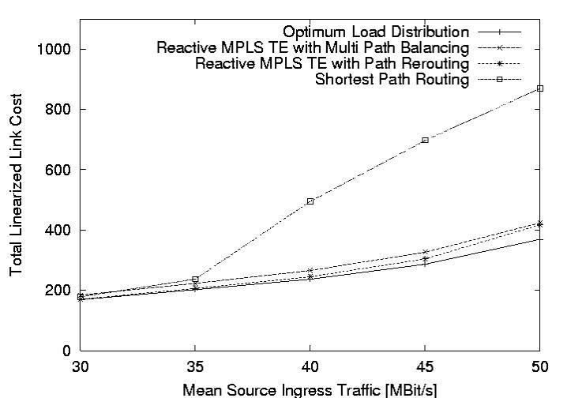
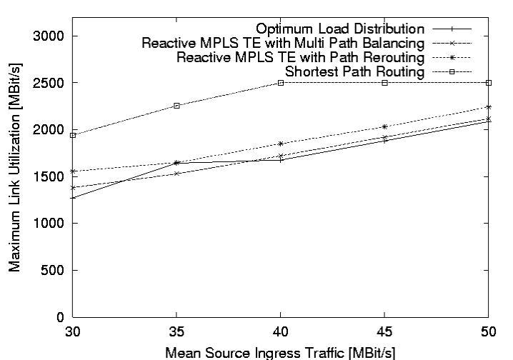
the path rerouting and multi path balancing algorithms
stop. The reached load distribution and the number of
performed rebalancing actions are evaluated. For the
convergence evaluation the mean LSP ingress traffic is
varied between 30Mbit/s and 50Mbit/s. For each mean
LSP load the convergence evaluation is repeated 1000
times. To evaluate the convergence behavior, the path
rerouting and the multi path balancing algorithm are
compared to the shortest path routing and to the optimal
load distribution. The optimal load distribution is received
by formulating the problem as a multi commodity linear
program. The constraints of this program are to keep the
link load below the maximum link capacity and to
guarantee that each node receives the same load of an
LSP as it sends out. In contrast to MPLS, this allows a
splitting of an LSP load over several links at each node in
the network. The objective of this linear program is to
minimize the total link cost. To solve the problem with a
linear program, the original cost function is approximated
with a piecewise linear cost function. Straight lines
connect the integer cost values (see Figure 6). The cost
value of link load L=0 is set to zero.

Link
Cost C

5
4
3
2
1
Bmax Used
Bandwidth L
Figure 6: Piecewise-linear cost function

In a second simulation run the behavior of the reactive
MPLS Traffic Engineering system is evaluated under
varying traffic load. The LSP load with a mean value of
28Mbit/s changes after a negative exponential distributed
time with a mean value of 1500sec. During the
simulation, router X (see Figure 5) increases the load of
each LSP with a factor of three. This models a traffic
variation e.g. due to a link failure in a neighboring
network. The rebalancing threshold is set to 1500Mbit/s
and the monitoring time interval is set to 300sec. The
monitoring intervals of the LSRs start randomly
distributed within the first 300sec. The LSP setup time is
set to 4sec and the rebalancing calculation time and the
topology update distribution time are set to 2sec.

5. Simulation Results

The convergence evaluation of the reactive MPLS TE
system shows an enormous decrease of the mean total

link cost and the maximum link utilization compared to
the shortest path routing (Figure 7 and Figure 8). Taking
the results of the shortest path routing with source ingress
traffic of 30Mbit/s as a reference, the ingress traffic can
be increased with about 50% using the reactive MPLS TE
system without increasing the maximum link utilization.
Comparing the reactive MPLS TE system to the optimum
load distribution, the achieved results of the total link
costs and maximum link utilizations are close to the
optimum load distribution.

Figure 7: Mean total link cost

Figure 8: Maximum link utilization

Comparing the multi path balancing and the path
rerouting, both approaches reaches the same total link
cost. The multi path balancing reaches a lower maximum
link utilization with a difference of about 100Mbit/s and
approaches the optimal load distribution closer. The
number of performed rebalancing actions of the two
approaches is compared in Figure 9. It shows, that both
approaches perform about 140 rebalancing actions with a
source ingress rate of 30Mbit/s. Increasing the source
ingress rate, the number of rebalancing actions of the path

Proceedings of the Eighth IEEE International Symposium on Computers and Communication (ISCC’03)
1530-1346/03 $17.00 © 2003 IEEE

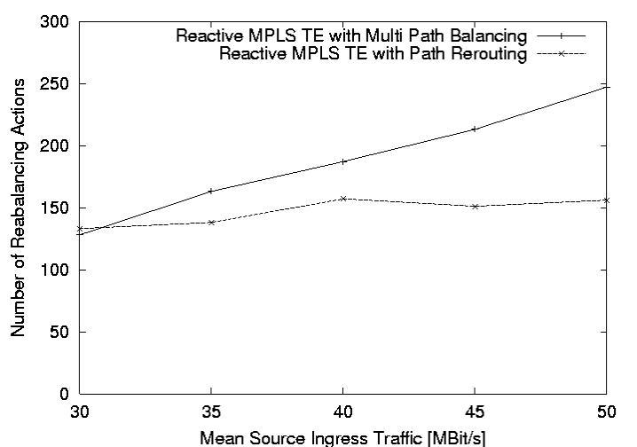
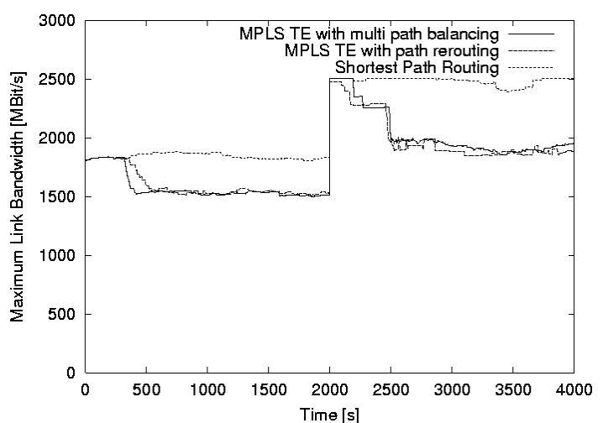
rerouting approach is nearly constant, while it increases
for the multi path balancing approach linearly up to 250.
To derive the convergence time from the number of
rebalancing actions, it has to taken into account that due
to the additional LSP setup time path rerouting actions are
approximately twice as long as multi path balancing
actions. It follows that the multi path balancing converges
faster in the presented scenario. The amount of the
switched data of both approaches is equal.

Figure 9: Mean number of rebalancing actions

The system behavior under varying traffic load is
shown in Figure 10. It takes 300sec, that the load of each
LSP is monitored and flooded through the network. Then
the path rerouting approach and the multi path balancing
approach starts to rebalance the load until no link load is
above the rebalancing threshold. The multi path balancing
converge faster than the path rerouting due to the
approximation that a path rerouting action is twice as long
as a multi path balancing action.

Figure 10: Maximum link utilization over the time

After 2000sec router X increases its ingress LSP loads
with the factor of three and the maximum link load
increases up to 100% of the link capacity. At the end of
the next monitor interval of router X, the load change is
recognized and the rebalancing process starts. The finally
reached maximum link utilization is below 80% of the
link capacity. In the presented scenario the monitoring
interval length mainly influences the convergence speed.

6. Conclusion

In this paper a scalable distributed reactive MPLS
traffic engineering system is presented. The distributed
TE units exchange periodically routing update messages
to actualize their link load view. The exchanged messages
are also used to coordinate the load rebalancing actions of
the TE units, which prevents the system from routing
oscillations. The reactive MPLS TE system is realized
with path rerouting and with multi path balancing. To
evaluate the performance of the system in realistic
network scenarios, a scalable rate-based simulation
environment is used. For the investigated scenario, the
simulation results show an enormous performance
increase compared to the shortest path routing. It is also
shown, that the both the path rerouting and the multi path
balancing produce results close to the optimum load
distribution. The results of both approaches are
comparable, while the multi path is considered to reach
lower maximum link utilizations and converges faster.
In future work the convergence speed of the system is
further improved. Therefore the gradient projection
algorithm for the multi path balancing is integrated in the
system. Additionally the monitor interval length is
dynamically adapted due to changes of the LSP load.

REFERENCES
[1] A. Elwalid, C. Jin, S. Low, I. Widjaja, “MATE: MPLS
Adaptive Traffic Engineering”, Infocom 2001
[2] www.ist-tequila.org
[3] P. Trimintzios, L. Georgiadis, G. Pavlou, D. Griffin, C.F.
Cavalcanti, P. Georgatsos, C. Jacquenet, “Engineering the
Multi-Service Internet: MPLS and IP-based Techniques”,
ICT2001
[4] D. Gao, Y. Shu, S. Liu, “Delay-based adaptive load
balancing in MPLS networks”, ICC2002
[5] E. Dinan, D. Awduche, B. Jabbari, „Optimal Traffic
Partitioning in MPLS Networks“, NETWORKING 2000
[6] D. Bertsekas, R. Gallager, „Data Networks“, Prentice-Hall,
1991
[7] Q. Ma, P. Steenkiste, H. Zhang, „Routing High-bandwidth
Traffic in Max-min Fair Share Networks“, SIGCOMM 1996
[8] D. Katz, D. Yeung, K. Kompella, „Traffic Engineering
Extensions to OSPF Version 2”, Internet Draft <draft-katz-
yeung-ospf-traffic-09.txt>, 2002

Proceedings of the Eighth IEEE International Symposium on Computers and Communication (ISCC’03)
1530-1346/03 $17.00 © 2003 IEEE

